# ABOUT THE APP

## OVERVIEW

**Destinique** is a comprehensive travel companion designed to provide users with a personalized and immersive travel experience. The app offers a destination guides, insider tips, and real-time information to help travelers navigate and explore new destinations with confidence.

Destinique is your ultimate travel companion, providing insider knowledge and expert advice to help you plan and enjoy your trip. With detailed destination guides, interactive maps, and real-time information, you'll be able to navigate unfamiliar places with ease. Plus, with features like personalized recommendations and social sharing, you'll be able to make the most of your travels. from popular attractions and hidden gems to restaurants and accommodations, destinique has everything you need to plan and enjoy.

## User 1: Traveler

1. A feature that provides personalized recommendations for unique, local experiences because, it helps discover hidden gems and creates unforgettable memories.
2. A feature that provides customizable itinerary building, budget tracking, and real-time scheduling because, it enables efficient trip planning and reduces and maximizes trip enjoyment.
3. A feature like a for you page where user can view images and short videos of different places other traveler have gone through because, it will help the users to decide where to go based on visual appeal and comfort.
4. A feature where user can add, recommend and suggest affordable places base on user’s budget because, it helps them to enjoy their trips without over spending.
5. A feature that connects user with fellow travelers and locals because, it helps to build friendships and share experiences through accommodations and events.

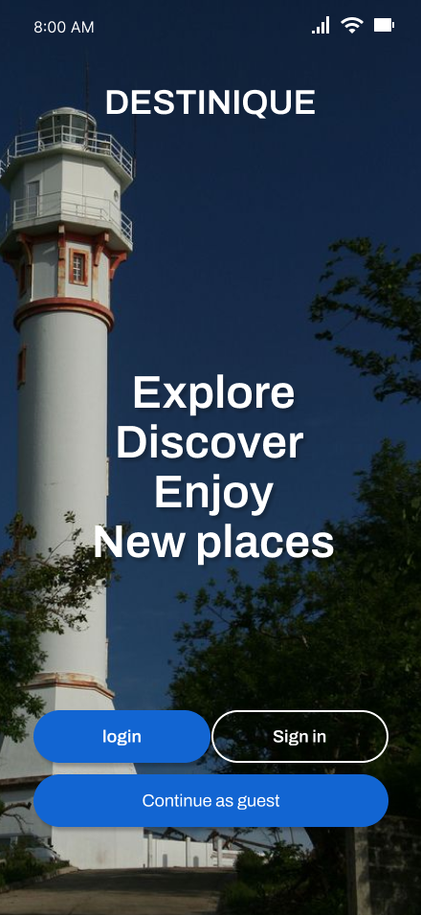

Splash Screen Log-in

**Description:**

This is the feature where the user logs in or sign-up to continue in using the app.

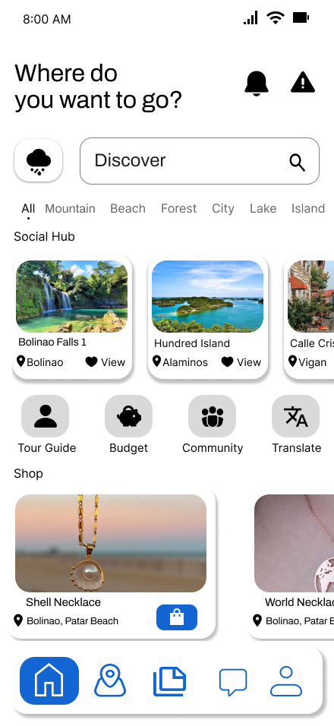

**Descriptions:**

This is the interface where you can see your activity log on the app.

Dashboard

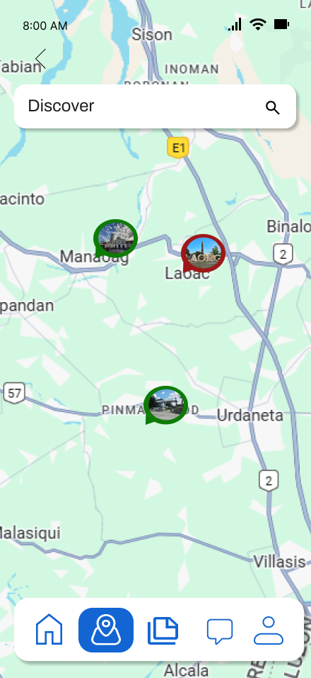

**Descriptions:**

The first screen features a map view labeled "Discover," displaying various location pins with thumbnail images, likely representing tourist spots or local attractions. Users can interact with the map to explore different areas, supported by a clean search bar at the top for easy navigation. The bottom navigation bar includes intuitive icons for home, map, shop, chat, and profile access, ensuring smooth user experience.

Maps

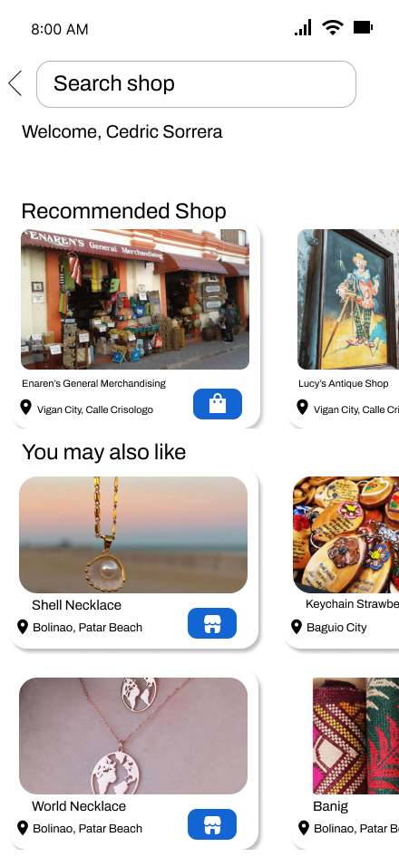

**Descriptions:**

The second screen presents a personalized shopping interface, greeting the user by name and offering a search bar to find specific shops. Below are sections like “Recommended Shop” and “You may also like,” showcasing local stores and products with images, names, locations, and store icons. This screen effectively combines product discovery with visual appeal, emphasizing handcrafted and local items like necklaces and keychains. The layout uses soft shadows and rounded cards for a modern, friendly look, enhancing overall usability.

Shop Recommendations

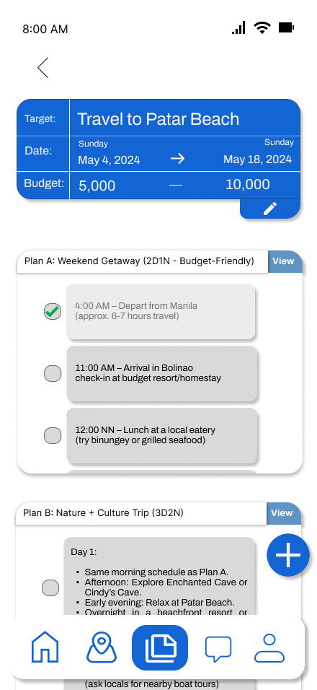

Descriptions:

This screen displays a detailed travel planning interface for a trip to Patar Beach. Users can specify their travel dates and budget range, shown here as May 4 to May 18, 2024, with a budget between ₱5,000 and ₱10,000. Two trip plans are offered: Plan A is a 2-day weekend getaway with scheduled departure, arrival, and meal times. Plan B is a 3-day nature and culture trip including visits to local caves and beachfront relaxation. The interface includes selection buttons for each plan and navigation icons at the bottom for accessing other app features.

ItItenirary

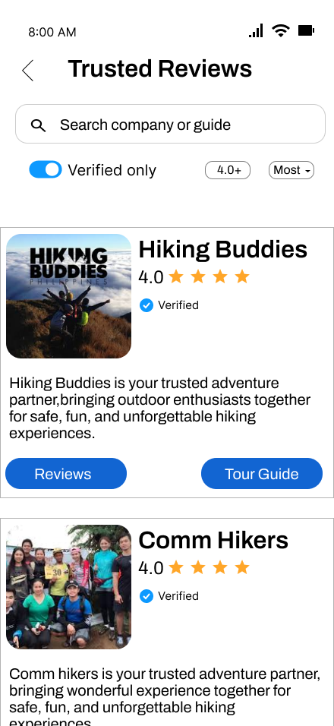

**Descriptions:**

This screen is a mobile user interface design for a “Trusted Reviews” section of an app, likely related to outdoor adventures or tourism. At the top, it features a search bar for users to find companies or guides, alongside toggles for filtering verified listings and selecting a minimum rating (4.0+) and sorting preference. Below, two verified hiking service providers are listed: “Hiking Buddies” and “Comm Hikers,” both rated 4.0 stars. Each listing includes a name, image, star rating, a brief description of the service, and action buttons labeled “Reviews” and “Tour Guide.” The layout is clean, user-friendly, and focuses on building trust through verified reviews.

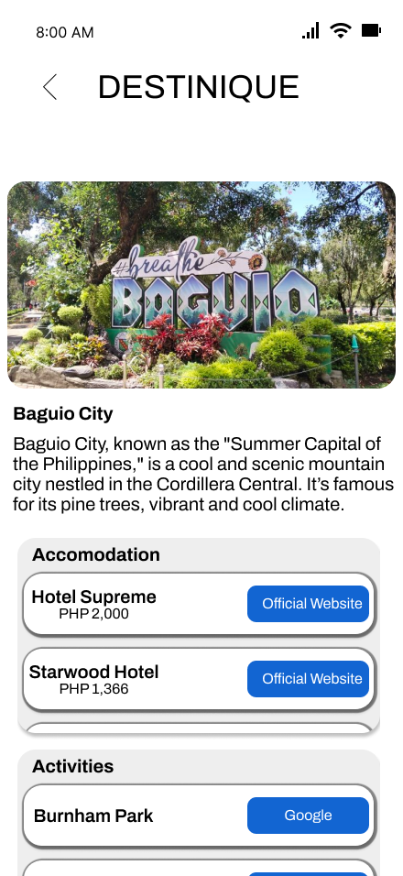

**Descriptions:**

This screen from the “DESTINIQUE” app showcases a search and budget filtering interface for travel destinations. Users can enter a keyword and set a budget range (₱5,000–₱20,000) to find matching vacation spots. Two featured destinations are displayed: Baguio City, noted for its cool climate and vibrant cultural attractions, and Patar Beach, a serene coastal getaway. Each destination card includes a photo, a brief description, and an estimated budget range for visiting. A “View” button is provided to access more details or trip plans related to each destination.

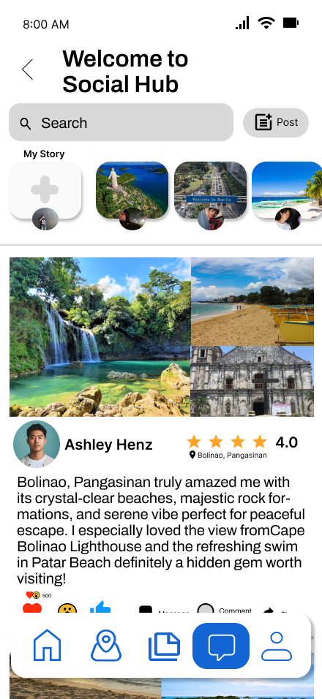

**Descriptions:**

This screen displays the main feed of a social app titled "Welcome to Social Hub." At the top, users can search for content or create a post using the Post button. Below that, there's a "My Story" section where users can upload and view story updates, similar to common social media formats. The feed features a post by Ashley Henz, showcasing travel photos of Bolinao, Pangasinan with a 4.0-star rating and a short review describing the beauty of the destination. The post highlights attractions like Cape Bolinao Lighthouse and Patar Beach, emphasizing relaxation and nature. Users can interact with posts using reaction icons (like, love, wow), and share or comment as indicated by icons at the bottom. A fixed navigation bar with home, location, files, chat, and profile icons allows easy switching between sections of the app. The overall design is clean, user-friendly, and visually appealing with vivid imagery and straightforward navigation.

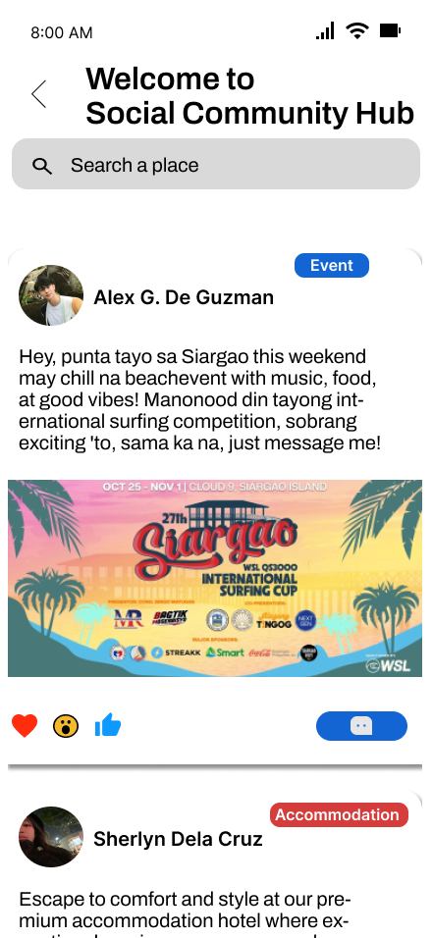

**Descriptions:**

This screen is from a variation of the app titled "Welcome to Social Community Hub," which seems to focus more on community events and services. The search bar now invites users to “Search a place,” hinting at location-based content discovery. The top post by Alex G. De Guzman promotes an upcoming beach event in Siargao, encouraging friends to join a chill weekend with music, food, and a surfing competition. A colorful event poster enhances visual engagement, and a blue “Event” tag categorizes the post. Below that, Sherlyn Dela Cruz shares a post about a premium accommodation option, marked with a red “Accommodation” label. The layout supports social interaction with reaction buttons, comments, and messaging options. This screen illustrates how the app blends social sharing with event promotion and local business advertising. It maintains consistency in design while slightly adjusting features for a more community-oriented focus.

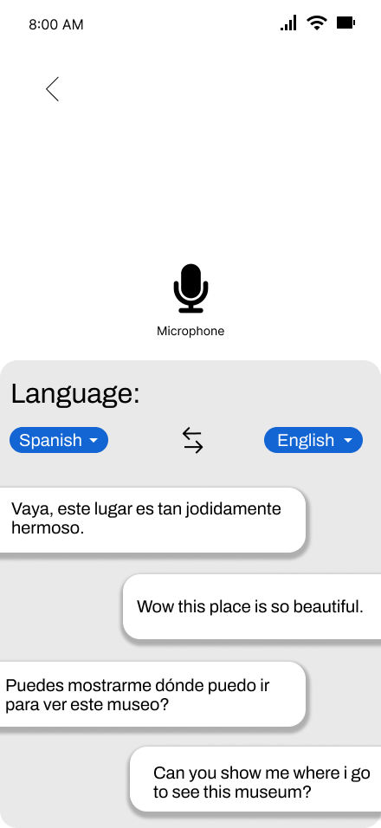

**Descriptions:**

Language Translation Interface This screen focuses on language translation functionality. It offers two main input methods Microphone and Camera allowing users to speak or capture text for translation. This makes the interface versatile for different communication needs. Below the input icons, a section labeled "Language" allows users to select source and target languages, with a default setting from Spanish to English. A bi-directional arrow icon between the two dropdowns makes it easy to swap the selected languages, enhancing user convenience for multilingual interactions.

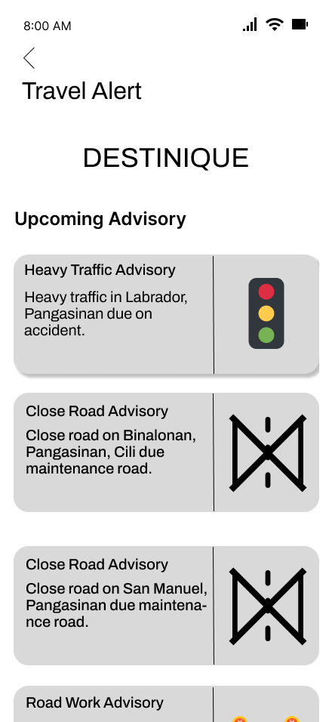

**Descriptions:**

The first screen features a map view labeled "Discover," displaying various location pins with thumbnail images, likely representing tourist spots or local attractions. Users can interact with the map to explore different areas, supported by a clean search bar at the top for easy navigation. The bottom navigation bar includes intuitive icons for home, map, shop, chat, and profile access, ensuring smooth user experience.

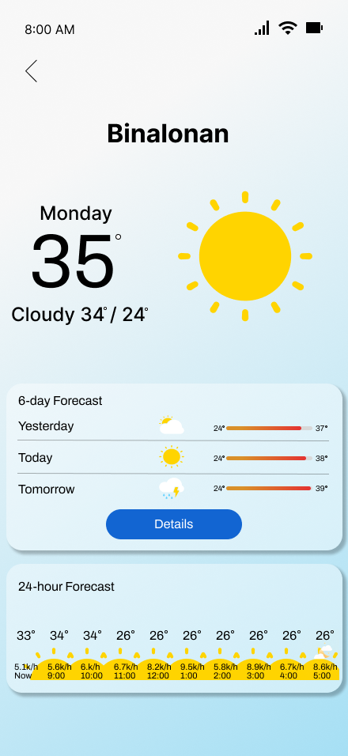

**Descriptions:**

Weather Forecast Interface This screen displays the weather forecast for Binalonan. At the top, the current time (8:00 AM) is shown, followed by the day (Monday) and the current temperature of 35°C. A large sun icon indicates clear weather, and below that, the conditions are described as “Cloudy,” with temperature ranges of 34°/24°C. Further down, there is a "6-day Forecast" panel showing weather summaries for yesterday, today, and tomorrow with icons and temperature bars for easy visual comparison. A “Details” button is provided for more in-depth weather data. At the bottom, the "24-hour Forecast" section gives hourly updates on temperature and wind speed from 9:00 AM to 5:00 PM, helping users plan their day with real-time insights.